



DevOps-Driven Portfolio Website with Docker, CI/CD, and Cloud Deployment.


DevOps-Driven Portfolio Website with Docker, CI/CD, and Cloud Deployment.
STUDENT LEARNING ASSESSMENT MODELS - PROJECTS / PRODUCTS
Bachelor of Technology
in
CSE (Artificial Intelligence & Machine Learning)
by

Manideep Mallaram

24951A6695

Department of
CSE (Artificial Intelligence & Machine Learning)

INSTITUTE OF AERONAUTICAL ENGINEERING
(Autonomous)

Dundigal, Hyderabad - 500 043, Telangana

April, 2026
© 2026, Manideep Mallaram All rights reserved.

DECLARATION
I certify that
- the work contained in this report is original and has been done by me under the guidance of my supervisor(s).
- the work has not been submitted to any other Institute for any degree or diploma.
- I have followed the guidelines provided by the Institute in preparing the report.
- I have conformed to the norms and guidelines given in the Ethical Code of Conduct of the Institute.
- whenever I have used materials (data, theoretical analysis, figures, and text) from other sources, I have given due credit to them by citing them in the text of the report and giving their details in the references. Further, I have taken permission from the copyright owners of the sources, whenever necessary.

Place: Signature of the Student
Date: Roll No:

APPROVAL SHEET
This project report entitled DevOps-Driven Portfolio Website with Docker, CI/CD, and Cloud Deployment.Submitted by Manideep Mallaram is approved for the award of the Degree Bachelor of Technology in CSE (Artificial Intelligence & Machine Learning).

Supervisor Head of the department

Date:
Place:

ABSTRACT
This project presents a DevOps-driven portfolio website developed to showcase modern web development practices integrated with automated deployment workflows. The application is built using HTML, CSS, and JavaScript, providing a responsive and interactive user interface. It incorporates features such as animated transitions using AOS, modal-based displays for education and certifications, and a dynamic skills section with toggle functionality. The user interface follows a modern design approach with gradient backgrounds, glass-style components, and well-structured layouts to enhance usability and visual appeal.
From a DevOps perspective, the application is served through a lightweight Node.js server and containerized using Docker to ensure consistency across different environments. A continuous integration and continuous deployment (CI/CD) pipeline is implemented using GitHub, enabling automatic build and deployment whenever code changes are pushed. The application is deployed on the Render cloud platform, ensuring high availability, scalability, and ease of access.
This project demonstrates the effective integration of frontend development with DevOps principles such as automation, containerization, and cloud deployment, resulting in a production-ready application that reflects real-world software engineering practices and industry standards.

Keywords: DevOps, CI/CD Pipeline, Docker, Containerization, Cloud Deployment, Node.js, Responsive Web Design, Automation, GitHub, Web Application.

CONTENTS

Name of the Content | Page No.
Title Page | II
Declaration | III
Approval Sheet | IV
Abstract | V
Contents | VI
List of Tables | VII
List of Figures | VII
List of Abbreviations | IX
Chapter 1 – Introduction | 1
1.1 Introduction | 1
1.2 Objectives | 1
1.3 Requirement Specifications | 2
1.3.3 Functional Requirements | 2
Chapter 2 – Literature Survey | 3
2.1 Literature survey and Existing works | 7
Chapter 3 – System Requirements | 8
3.1 Dataset | 9
3.2 Packages and Modules | 10
Chapter 4 – Proposed Methodology | 11
Chapter 5 – Implementation | 13
Chapter 6 – Result and Analysis | 18
Chapter 7 – Conclusion and Future Scope | 20
References | 21

List of Tables

Table No | Table Name | Page No
Table 1 | Hardware requirements | 6-7
Table 2 | Software requirements | 8
Table 3 | Summary of existing works | 8
Table 4 | Modules Used in the System | 10
Table 5 | Metric analysis | 19

List of Figures
Table No | Table Name | Page No
Figure 1 | Portfolio Home / Landing Page | 13
Figure 2 | Portfolio Dashboard / Sections View | 14
Figure 3 | System Architecture Block Diagram | 16
Figure 4 | Projects / Skills Display | 18

List of Abbreviations

Abbreviation | Definition
UI | User Interface
UX | User Experience
HTTP | HyperText Transfer Protocol
CI | Continuous Integration
CD | Continuous Deployment
Docker | Containerization Platform
Container | Lightweight package
Git | Version Control System

  - Introduction

CHAPTER -1

INTRODUCTION

In today’s rapidly evolving digital landscape, personal branding and online presence have become essential for students and professionals to showcase their skills, projects, and achievements. A well-designed portfolio website serves as a central platform to present technical expertise, academic background, and professional profiles in a structured and visually appealing manner. However, building and deploying such applications efficiently while ensuring scalability, maintainability, and continuous updates presents significant technical challenges.
Traditional web development approaches often rely on static hosting or monolithic deployment methods, where development and deployment processes are loosely integrated. These methods can lead to inconsistencies across environments, difficulty in updates, and limited scalability when the application evolves. As a result, there is a growing need for modern development practices that support automation, reliability, and streamlined deployment workflows.
With the adoption of DevOps practices, it has become possible to bridge the gap between development and operations, enabling faster and more reliable software delivery. DevOps emphasizes automation, continuous integration, and continuous deployment (CI/CD), allowing applications to be built, tested, and deployed seamlessly. Additionally, containerization technologies such as Docker provide environment consistency by packaging applications along with their dependencies, ensuring smooth execution across different platforms.
Traditional deployment processes often involve manual configuration and setup, which are time-consuming and prone to errors. In contrast, modern cloud platforms combined with CI/CD pipelines automate the deployment lifecycle, improving efficiency and reducing human intervention. This enables developers to focus more on application development while ensuring that updates are delivered quickly and reliably.
To address these challenges, this project presents a DevOps-driven portfolio website designed with modern web technologies and automated deployment practices. The system integrates a responsive and interactive frontend with a Node.js server, containerized using Docker, and deployed on a cloud platform with CI/CD support. The application is designed to provide a seamless user experience while maintaining high availability and scalability.
The proposed solution demonstrates how integrating DevOps methodologies with web development enhances system efficiency, simplifies deployment, and ensures continuous delivery. Ultimately, this project highlights the importance of automation and modern deployment strategies in building production-ready applications that meet current industry standards.

Objectives
- To design and develop a responsive portfolio website that showcases personal skills, projects, and achievements in a structured manner.
- To implement interactive UI features such as animations, toggles, and modal popups to enhance user experience.
- To integrate DevOps practices by setting up a CI/CD pipeline for automated build and deployment.
- To containerize the application using Docker to ensure consistency across different environments.
- To deploy the application on a cloud platform (Render) for accessibility and reliability.

Functional Objectives:

To provide a structured portfolio interface with sections such as About, Skills, Projects, Education, Certifications, and Contact.

To enable basic interactivity using features like skill toggling and modal popups for displaying additional information.

To ensure responsive design so the website works across desktop and mobile devices.

To integrate external links such as GitHub and LinkedIn for professional visibility.
- To serve the application using a Node.js server for reliable access

Requirement Specifications
The DevOps-driven portfolio website requires both hardware and software components to support efficient development, deployment, and access. The hardware setup should be capable of running web-based applications and basic development tools, while handling standard user interactions smoothly.
The system is developed using modern web technologies and DevOps tools. It requires a stable internet connection for cloud deployment and accessing services like GitHub and Render. The application includes a frontend built with HTML, CSS, and JavaScript, and a backend served using Node.js. It is containerized using Docker to ensure consistent execution across different environments and deployed on a cloud platform for reliable access.

Functional Requirements
- Allow users to view different sections such as About, Skills, Projects, Education, Certifications, and Contact
- Provide a user-friendly interface with interactive elements like animations, toggles, and modal popups
- Display skills dynamically using toggle functionality
- Show education and certification details through modal popups
- Enable navigation across sections with smooth scrolling

  - Literature Survey

CHAPTER 2 LITERATURE SURVEY

Overview of Web-Based Portfolio Systems
Web-based portfolio applications have become an essential tool for individuals to showcase their skills, projects, and achievements in a structured and accessible manner. These systems provide a centralized platform for professional representation. However, traditional portfolio websites often lack interactivity, scalability, and efficient deployment strategies. Recent studies emphasize the need for modern web technologies to enhance user experience and maintain performance under varying user access conditions [1].
Role of Modern Web Design in User Experience
Modern web design focuses on responsiveness, interactivity, and visual appeal to improve user engagement. Technologies such as CSS animations, responsive layouts, and dynamic content handling significantly enhance usability. Research indicates that well-designed user interfaces contribute to better accessibility and retention, making them a critical aspect of portfolio-based applications [2].
DevOps Practices in Web Application Development
DevOps practices have transformed how web applications are developed and deployed. By integrating development and operations, DevOps enables faster delivery, improved collaboration, and automation of workflows. Continuous Integration and Continuous Deployment (CI/CD) pipelines automate testing and deployment, reducing manual effort and increasing reliability in application delivery [3].
Challenges in Traditional Web Deployment Methods
Traditional deployment approaches often involve manual configuration and lack automation, leading to inconsistencies and higher chances of errors. These methods also make scaling and updating applications more complex. Studies highlight that such limitations can hinder performance and delay delivery, especially in evolving applications [4].
Cloud-Based Deployment for Web Applications
Cloud platforms provide scalable and reliable infrastructure for hosting web applications. Services like Render enable simplified deployment with minimal configuration. Research shows that cloud deployment improves availability, scalability, and overall system performance, making it a preferred choice for modern applications [5].
Containerization Using Docker
Containerization has become a key component in modern DevOps workflows. Docker allows applications to be packaged with their dependencies into containers, ensuring consistent execution across different environments. Studies indicate that containerization enhances portability, reduces environment-related issues, and simplifies deployment processes [6].
Continuous Integration and Continuous Deployment (CI/CD)
CI/CD pipelines play a vital role in automating the software development lifecycle. Continuous Integration ensures that code changes are automatically built and tested, while Continuous Deployment allows seamless delivery to production environments. Tools such as GitHub Actions are widely used to implement these pipelines efficiently [7].
Integration of Frontend and Backend Systems
Modern web applications require seamless integration between frontend interfaces and backend services. Node.js is commonly used to serve web applications efficiently and handle client requests. Research highlights that proper integration improves application performance and ensures smooth data flow between components [8].

Scalability and Performance Optimization
Scalability is important even for lightweight web applications to handle increasing user access. Techniques such as efficient resource management, optimized UI rendering, and cloud-based hosting contribute to improved performance. Studies show that scalable and optimized systems provide better user experience and long-term maintainability [9].

Comparison of Existing Web Application Architectures
Existing web application systems can be broadly categorized into traditional deployment-based systems and DevOps-enabled architectures. Traditional approaches often involve simple static hosting or tightly coupled setups, where frontend and backend components are managed together. While these systems are easy to develop and deploy initially, they become difficult to maintain, update, and scale as the application evolves. Any change in the system may require manual redeployment, increasing effort and the risk of errors.
In contrast, DevOps-enabled architectures focus on automation, modularity, and efficient deployment practices. By integrating tools such as CI/CD pipelines, applications can be built, tested, and deployed automatically with minimal manual intervention. Containerization using Docker ensures that applications run consistently across different environments, improving reliability and reducing deployment issues.
Deployment strategies also differ significantly between these approaches. Traditional methods rely on manual configuration, which is time-consuming and error-prone, whereas DevOps practices automate the entire lifecycle, from code integration to production deployment. Cloud platforms further enhance this process by providing scalable and reliable hosting solutions.
For modern web applications like a portfolio website, reliability, ease of updates, and consistent deployment are important. Therefore, DevOps-based architecture is preferred as it enables automation, reduces complexity, and ensures efficient delivery with minimal downtime.

Existing Works
Early web applications were primarily developed using monolithic architectures, where all components of the system were tightly coupled into a single codebase. According to Bass et al. (2015) [1], monolithic systems are relatively simple to design and implement in the initial stages. However, as the application grows, these systems become increasingly difficult to scale, maintain, and update due to their tightly integrated structure.
Fowler and Lewis (2014) [2] introduced microservices architecture as an alternative approach, focusing on dividing applications into smaller, independent services. Newman (2015) [3] further emphasized that microservices improve scalability, flexibility, and fault isolation, allowing each service to be developed, deployed, and maintained independently. This approach has proven effective in handling modern application requirements.
Merkel (2014) [4] introduced containerization through Docker, which allows applications to be packaged along with their dependencies into lightweight containers. This ensures consistency across development, testing, and production environments. Containerization reduces environment-related issues and simplifies deployment processes.
Kim et al. (2016) [5] discussed the adoption of DevOps practices, highlighting improved collaboration between development and operations teams. The study showed that DevOps enables faster deployment cycles, reduces errors, and enhances overall system efficiency. Forsgren et al. (2018) [6] further demonstrated that organizations implementing CI/CD pipelines achieve higher deployment frequency and improved software quality.
Fielding (2000) [7] introduced REST architecture, which forms the foundation for communication in modern web applications. RESTful APIs enable efficient interaction between system components. Burns (2018) [8] emphasized the importance of distributed system design, focusing on scalability, reliability, and fault tolerance in cloud-native applications.
Hightower et al. (2017) [9] explored container orchestration using Kubernetes, which enables automated deployment, scaling, and management of containerized applications. This approach improves system resilience and ensures efficient resource utilization in large-scale environments.
Richards (2015) [10] analyzed software architecture patterns and highlighted the importance of modular design in improving system maintainability and performance. Cockcroft (2015) [11] demonstrated how organizations like Netflix use microservices and DevOps practices to achieve high availability, scalability, and continuous delivery.
Cloud platforms such as Google Cloud [12] and Amazon Web Services [13] provide scalable infrastructure and tools for deploying modern applications. These platforms support load balancing, auto-scaling, and fault tolerance, which are essential for maintaining system performance under varying workloads. GitHub Actions [14] further supports automation by enabling CI/CD pipelines for building, testing, and deploying applications efficiently.
Modern web development practices, as outlined by Mozilla Developer Network [15], emphasize responsive design, frontend-backend integration, and performance optimization. The Node.js Foundation [16] highlights the use of server-side JavaScript for building efficient and scalable backend services.
Kleppmann (2017) [17] explored data-intensive application design, focusing on reliability, scalability, and maintainability in distributed systems. Recent studies (2022–2024) [18] indicate that integrating DevOps practices with scalable architectures significantly enhances application performance and user experience.
Further research [19] highlights the importance of automation, monitoring, and continuous improvement in maintaining system reliability and reducing downtime. Finally, modern cloud-based deployment platforms such as Render and Vercel [20] enable efficient hosting, automatic deployment, and simplified infrastructure management for modern web applications.

TABLE 1: SUMMARY OF EXISTING WORKS

S.No | Author Name | Technologies Used | Key Findings | Result | Limitations
1 | Bass et al. (2015) | DevOps Architecture | DevOps improves collaboration | Faster delivery | Requires cultural shift
2 | Fowler & Lewis (2014) | Microservices | Independent services improve scalability | High flexibility | Complex system management
3 | Newman (2015) | Microservices | Modular design enhances maintainability | Scalable systems | Inter-service communication overhead
4 | Merkel (2014) | Docker | Containerization ensures consistency | Easy deployment | Requires container management
5 | Kim et al. (2016) | DevOps Practices | CI/CD improves deployment speed | Reduced downtime | Toolchain complexity
6 | Forsgren et al. (2018) | CI/CD | Automation improves performance | Faster releases | Needs proper monitoring
7 | Fielding (2000) | REST APIs | Standard communication between services | Scalable APIs | Stateless limitations
8 | Burns (2018) | Distributed Systems | Scalable system design | High availability | Complex debugging
9 | Hightower et al. (2017) | Kubernetes | Container orchestration | Automated scaling | Learning curve
10 | Richards (2015) | Architecture Patterns | Modular systems improve performance | Better maintainability | Design complexity
11 | Cockcroft (2015) | Microservices + DevOps | High scalability in real systems | Continuous delivery | Requires monitoring tools
12 | Google Cloud (2023) | Cloud Computing | Scalable infrastructure | High reliability | Cost management issues
13 | AWS (2023) | Cloud Services | Elastic scaling | Efficient resource use | Vendor lock-in
14 | GitHub (2023) | CI/CD Tools | Automated workflows | Faster deployment | Configuration complexity
15 | MDN (2023) | Web Technologies | Frontend-backend integration | Better UX | Browser compatibility issues
16 | Node.js Foundation (2023) | Backend Runtime | Non-blocking I/O improves performance | Scalable backend | Callback complexity
17 | Kleppmann (2017) | Data Systems | Reliable data handling | High consistency | Complex design
18 | Recent Studies (2022) | DevOps + Microservices | Improved system efficiency | Better performance | Integration challenges
19 | Recent Studies (2023) | Cloud + CI/CD | Reduced deployment time | Continuous updates | Security concerns
20 | Modern Platforms (2024) | Render, Vercel | Easy deployment & hosting | High availability | Limited customization

Chapter:3 SYSTEM REQUIREMENTS
The system requires a combination of hardware and software components to ensure efficient meme generation, storage, and real-time delivery. The system is designed to be scalable, reliable, and capable of handling multiple user requests simultaneously using microservices architecture and DevOps practices.

Hardware Requirements:

Table 2:Hardware Requirements

S.No | Component | Specification
1 | Processor | Intel Core i5 / i7 or higher
2 | RAM | Minimum 8 GB
3 | Storage | At least 10 GB free space
4 | Internet | Stable internet connection
5 | GPU (Optional) | Required only for advanced processing (not mandatory)

Software Requirements:

Table 3:Software Requirements

S.No | Software / Tool | Purpose
1 | Node.js / Java / Python | Backend development
2 | HTML, CSS, JavaScript | Frontend development
3 | Docker | Containerization
4 | Git & GitHub | Version control
5 | GitHub Actions / CI/CD Tools | Automation and deployment
6 | Express.js / Spring Boot / Flask | Backend frameworks
7 | MongoDB / MySQL | Database for meme storage
8 | Visual Studio Code / IntelliJ IDEA | Development environment
9 | Google Chrome / Microsoft Edge | Testing and debugging
10 | Render / Vercel | Cloud deployment

Data Requirements
The system uses portfolio content such as personal details, project information, skills, education, and certifications instead of traditional datasets. These data elements are structured and displayed dynamically through the user interface.The application primarily handles static and semi-dynamic data stored within the frontend or managed through simple configurations. Information such as project descriptions and profile links is organized to ensure easy access and clear presentation.The system supports various formats of text, images, and links to enable flexible content representation. Proper data handling ensures consistency, smooth rendering, and reliable performance across different sections of the application.

Network Requirements
A stable internet connection is required for accessing the web application, integrating external platforms such as GitHub and LinkedIn, and deploying the system on cloud platforms like Render.
  - Data Sources and Content Handling
The portfolio system does not rely on traditional datasets such as machine learning or analytics data. Instead, it utilizes structured content including personal details, project information, skills, education, and certifications, which are displayed dynamically through the user interface.The system uses predefined content elements such as text, images, and links that form the core of the portfolio. These elements are organized within the application to ensure efficient access and smooth rendering across different sections.In addition to static content, the system integrates external links such as GitHub and LinkedIn to enhance professional visibility. These integrations allow users to access updated information directly from external platforms, ensuring relevance and accuracy.

Packages and Modules
The following packages, frameworks, and tools are used in the implementation of the DevOps-driven portfolio website. These technologies support frontend development, backend processing, and DevOps automation.
- Frontend: HTML, CSS, JavaScript, AOS (Animate On Scroll)
- Backend: Node.js
- Version Control: Git, GitHub
- Containerization: Docker
- CI/CD: GitHub Actions
- Cloud Deployment: Render

Table No:4 -Modules Used in the System

Package / Module | Version | Purpose
HTML / CSS / JavaScript | Latest | Frontend development and UI design
AOS Library | Latest | Smooth animations and scroll effects
Node.js | Latest | Backend server to serve static files
Express.js (Optional) | Latest | Lightweight server handling (if used)
Docker | Latest | Containerization for consistent deployment
Git & GitHub | Latest | Version control and code management
GitHub Actions | Latest | CI/CD pipeline for automated deployment
Render | Latest | Cloud platform for hosting and deployment
JSON | Standard | Data format for structured content handling

Methodology

CHAPTER-4 PROPOSED METHODOLOGY

The present work focuses on the design and development of a DevOps-driven portfolio website, developed to showcase personal skills, projects, education, and certifications through a modern, interactive, and responsive web interface. The system is designed not only as a presentation platform but also as a demonstration of modern DevOps practices such as containerization, automated deployment, and cloud hosting. The application ensures smooth performance, high accessibility, and ease of maintenance while following industry-relevant development workflows.
The system integrates multiple layers of application development, including frontend design, backend serving, deployment automation, and cloud-based hosting. Users interact with the system through a web-based interface that is designed using HTML, CSS, and JavaScript. The interface includes various sections such as About, Skills, Projects, Education, Certifications, and Contact, each structured to present information clearly and efficiently. Interactive elements such as toggle-based skill display, modal popups for education and certifications, and smooth animations using AOS enhance user engagement and provide a dynamic browsing experience.

Modules of the System
User Interface Module
This module is responsible for presenting the portfolio content to users in a structured and visually appealing manner. It includes all frontend components such as layout design, navigation, animations, and responsiveness. The UI is designed using modern styling techniques such as gradient backgrounds, glassmorphism effects, and flexible layouts to ensure compatibility across devices.
Content Management Module
This module manages all portfolio-related data, including personal details, project descriptions, skills, education records, and certification information. The content is structured within the application in a way that ensures easy modification and consistent rendering across different sections.
Interaction and Navigation Module
This module handles user interactions within the application. It includes features such as smooth scrolling, animated transitions using AOS, toggle functionality for displaying skills, and modal popups for detailed information. These features improve usability and provide a seamless browsing experience.
Backend Server Module
The backend is implemented using Node.js, which serves as a lightweight server for delivering static content. It ensures efficient handling of requests and smooth communication between the user interface and server environment. Although minimal, this module plays a crucial role in deployment and execution.
Containerization Module
This module uses Docker to package the application into a container. Containerization ensures that the application runs consistently across development, testing, and production environments. It eliminates dependency issues and simplifies the deployment process.
CI/CD Module
The CI/CD module automates the build and deployment process using GitHub Actions. Whenever changes are pushed to the repository, the pipeline is triggered automatically to build and deploy the updated application. This reduces manual intervention and ensures faster and reliable updates.
Cloud Deployment Module
This module handles the deployment of the application on a cloud platform such as Render. Cloud deployment ensures that the application is accessible globally, provides high availability, and supports scalability as needed.
System Integration Module
This module ensures smooth integration between all components, including frontend, backend, containerization, and deployment processes. It guarantees that the application functions as a unified system without performance issues or inconsistencies.

Detailed Working Methodology
The system follows a structured workflow where users access the portfolio through a web browser. The frontend interface loads the content dynamically and presents it through interactive components. When a user navigates through different sections, JavaScript handles the interaction logic, while CSS and AOS manage visual transitions and animations.
The Node.js server serves the application files and ensures that the website is delivered efficiently to the user. The application is containerized using Docker, which creates a standardized environment for execution. This ensures that the application behaves consistently regardless of the system it is deployed on.
The CI/CD pipeline is configured using GitHub Actions, which continuously monitors the repository for changes. Whenever new code is pushed, the pipeline automatically builds the application and deploys it to the cloud platform. This automation improves development efficiency and reduces the risk of deployment errors.
The application is hosted on Render, which provides a reliable and scalable environment. The cloud platform ensures that the application remains available at all times and can handle multiple users accessing it simultaneously.
To enhance performance, the system uses lightweight design principles, optimized assets, and efficient rendering techniques. Animations are handled carefully to ensure smooth transitions without affecting performance. The responsive design ensures compatibility across different devices, including desktops, tablets, and mobile phones.
Basic security measures such as proper content structuring and controlled deployment workflows are followed to ensure safe operation. Although the system does not involve sensitive data handling, maintaining structured and reliable deployment practices contributes to overall system stability.

Future Scope within Methodology
The modular design of the system allows easy expansion in the future. Additional features such as backend APIs, database integration, user authentication, and advanced DevOps tools like monitoring and logging can be incorporated without affecting the existing structure. The system can also be extended to support dynamic content updates and real-time data integration.

CHAPTER-5 IMPLEMENTATION

User Interaction Module
The User Interaction Module plays a crucial role in enabling users to interact with the portfolio system in a simple and efficient manner. This module serves as the primary interface between the user and the application, ensuring a smooth and responsive user experience.
The interface is designed using a modern layout with gradient backgrounds and glass-style components. Users can navigate through different sections such as About, Skills, Projects, Education, Certifications, and Contact. Interactive elements like buttons, toggles, and modals enhance usability and ensure seamless navigation across the application.
Figure 1: Home / Landing Page

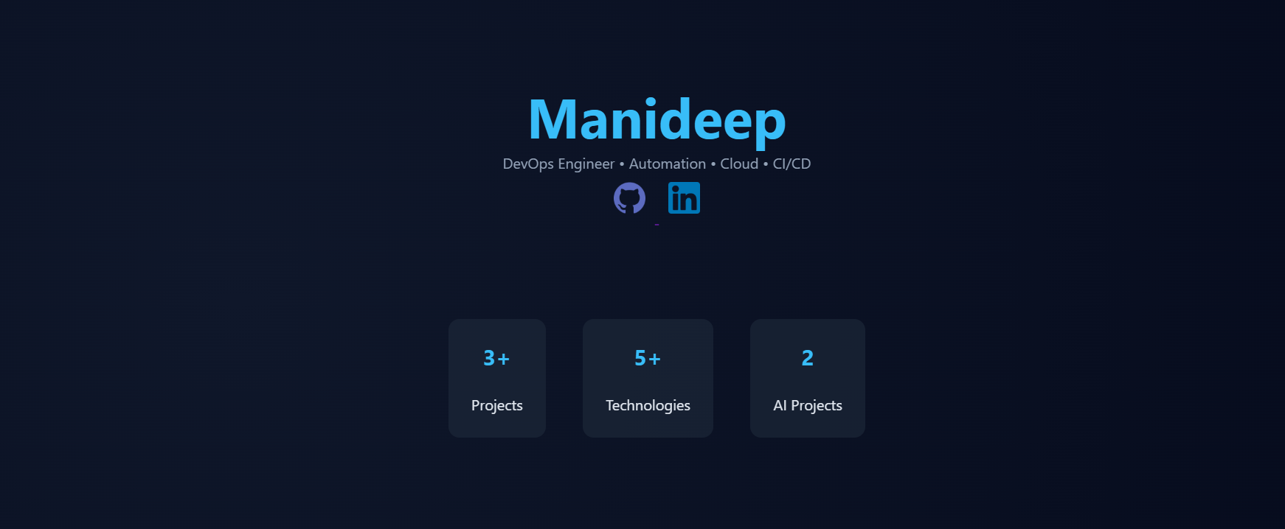
Dashboard / Portfolio Display Module
The main interface of the system acts as a dashboard that presents all portfolio information in an organized manner. It provides users with access to different sections through a structured layout.
The portfolio is divided into multiple sections for better usability:
- About Section – Displays personal information
- Skills Section – Uses toggle functionality for dynamic display
- Projects Section – Showcases completed work
- Education & Certifications – Displayed using modal popups
This design ensures an intuitive and engaging user experience while maintaining clarity and accessibility.
Figure 2: Portfolio Dashboard
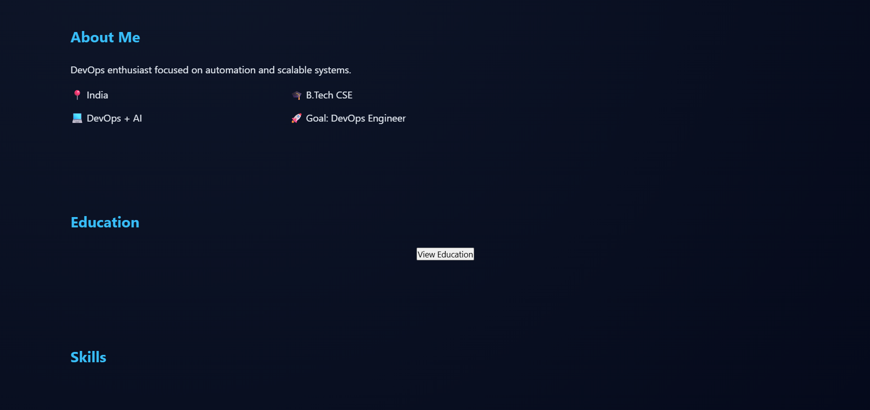

Implementation Details
The system is implemented using a frontend-backend integrated approach. The frontend is developed using HTML, CSS, and JavaScript, ensuring responsive design and interactive functionality. Animations are implemented using the AOS library to provide smooth transitions and enhanced visual effects.
The backend is built using Node.js, which serves static files and ensures efficient handling of requests. Although the backend logic is minimal, it plays an important role in deployment and execution of the application.
The application follows a modular structure where each component is designed independently but integrated seamlessly to form a complete system.

Processing Steps
User Interaction
The user accesses the portfolio through a web browser and navigates through different sections using the interface.
UI Rendering
The frontend dynamically renders content such as skills, projects, and other details using JavaScript and CSS.
Content Display
Interactive elements such as toggles and modals display additional information without reloading the page.
Server Handling
The Node.js server processes requests and serves the required files to the client efficiently.
Deployment Handling
The application is deployed using automated pipelines, ensuring that updates are reflected instantly.

Technology Used
- Frontend: HTML, CSS, JavaScript, AOS
- Backend: Node.js
- Containerization: Docker
- Version Control: Git & GitHub
- CI/CD: GitHub Actions
- Cloud Deployment: Render

DevOps Implementation
The system incorporates DevOps practices to automate and streamline the development lifecycle.
- Containerization:
The application is packaged using Docker to ensure consistency across environments.
- CI/CD Pipeline:
GitHub Actions is used to automate build and deployment processes whenever code changes are pushed.
- Cloud Deployment:
The application is hosted on Render, ensuring high availability and accessibility.
This approach reduces manual effort, minimizes errors, and improves deployment efficiency.

Performance
The system provides efficient performance with fast loading times and smooth navigation. The use of lightweight frontend design and optimized assets ensures minimal resource usage.
The application is capable of handling multiple users accessing the portfolio simultaneously without performance degradation. Cloud deployment further ensures reliability and consistent availability.

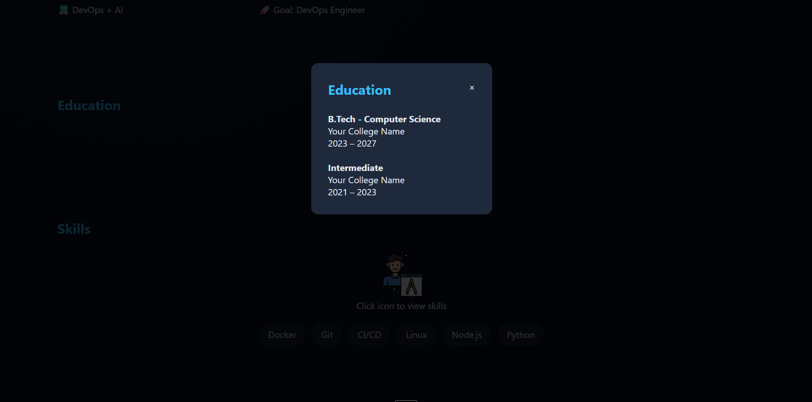

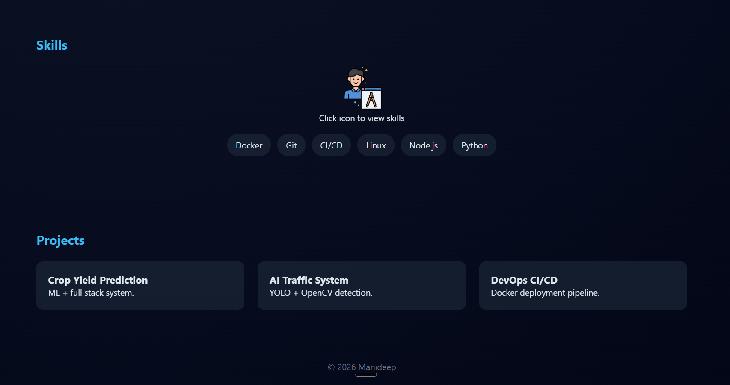

BLOCK DIAGRAM:
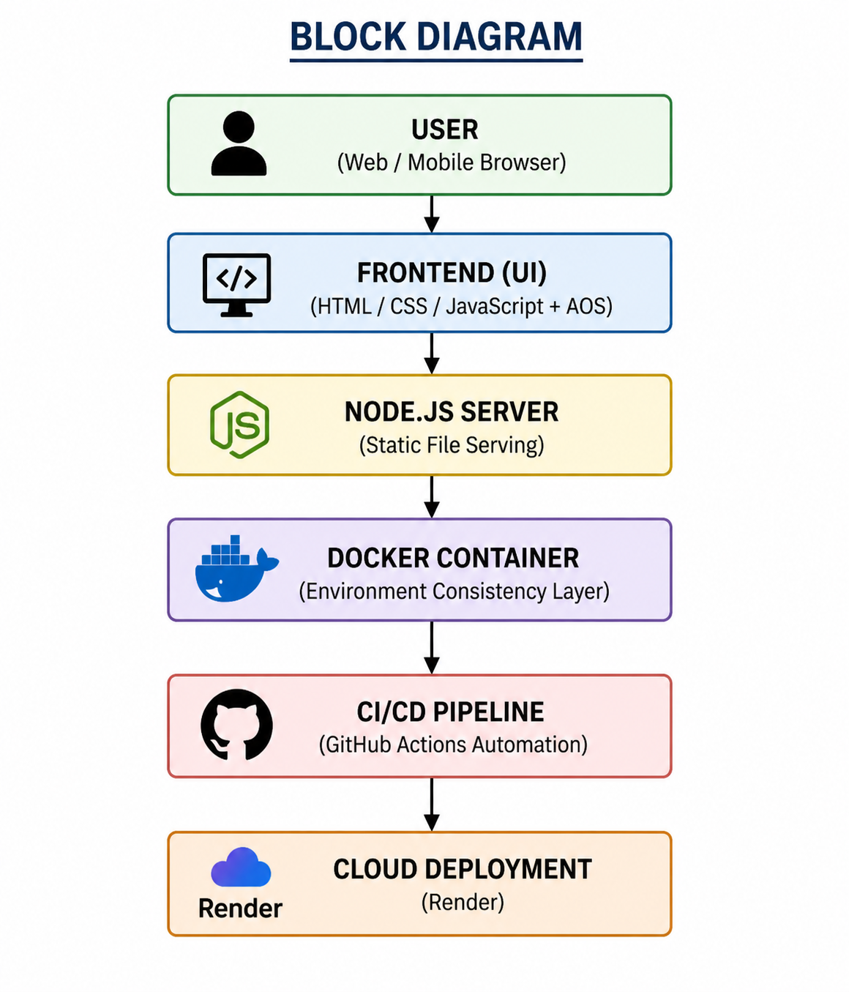

FIGURE 3 — System Architecture Block Diagram
Based on the system architecture diagram, the following is a detailed explanation of the workflow for the DevOps-driven portfolio website. The architecture follows a simplified layered design integrated with DevOps practices, enabling efficient content delivery, automated deployment, and consistent performance.
The workflow is divided into four main stages:

1. User Interaction and Request Handling
The process begins when the user accesses the portfolio through a web browser. The user interacts with the frontend interface, which includes sections such as About, Skills, Projects, Education, Certifications, and Contact.
User actions such as navigation, toggling skills, or opening modal popups are handled directly within the frontend. These interactions trigger requests that are processed by the backend server for content delivery.

2. Request Processing and Server Handling
Once the request is initiated, it is handled by the Node.js server, which serves static files and manages application responses efficiently.
- Request Handling: The server receives requests from the frontend
- Content Serving: Required HTML, CSS, and JavaScript files are delivered
- Efficient Processing: Ensures smooth communication between client and server
This stage ensures reliable delivery of application resources and smooth system operation.

3. UI Rendering and Content Processing
This stage focuses on displaying and managing content on the user interface.
- Dynamic Rendering: JavaScript updates content without reloading the page
- Interactive Features: Toggles, modals, and animations enhance usability
- Visual Enhancements: AOS animations provide smooth transitions
All portfolio data such as projects, skills, and certifications are displayed in an organized and interactive manner.

4. Output Display and User Experience
The final stage presents the processed content to the user.
- Frontend Display: Portfolio content is rendered instantly
- Smooth Navigation: Users experience seamless transitions across sections
- Responsive Design: Ensures compatibility across devices
The system ensures a smooth, fast, and engaging user experience with minimal latency.

Additional System Components
Containerization and Deployment
The application is containerized using Docker, which ensures consistent execution across development and production environments. This eliminates dependency issues and simplifies deployment.

CI/CD Integration
Continuous Integration and Continuous Deployment (CI/CD) pipelines are implemented using GitHub Actions. These pipelines automate building and deployment whenever code changes are pushed, improving efficiency and reducing manual errors.

Cloud Deployment
The system is deployed on the Render platform, which provides reliable hosting, scalability, and high availability. This ensures that the application is accessible at all times with consistent performance.

CHAPTER 6 RESULTS AND ANALYSIS
In this section, the performance and behavior of the DevOps-driven portfolio website are analyzed based on real-time usage and deployment conditions. The system was tested across multiple scenarios to evaluate its responsiveness, usability, reliability, and deployment efficiency.
The application successfully delivers a smooth and interactive user experience through a well-structured interface. Users can navigate between different sections such as About, Skills, Projects, Education, Certifications, and Contact without any noticeable delay. The integration of interactive components such as toggle-based skill display and modal popups enables dynamic content visualization without requiring page reloads, thereby improving overall usability.
The performance of the system is primarily evaluated based on response time and frontend rendering efficiency. Since the application is lightweight and optimized, it provides fast loading speeds and minimal latency during user interaction. The use of efficient CSS styling, optimized JavaScript execution, and AOS-based animations ensures smooth transitions and enhanced visual appeal without affecting performance.
The system also demonstrates strong compatibility across multiple devices and screen sizes. Responsive design techniques ensure that the application adapts seamlessly to desktops, tablets, and mobile devices. This improves accessibility and allows users to interact with the portfolio from different platforms without any loss in functionality or design consistency.
From a backend perspective, the Node.js server efficiently serves static content and handles user requests with minimal overhead. Even though the backend logic is simple, it plays a crucial role in ensuring consistent content delivery and smooth integration with deployment infrastructure.
A significant aspect of the system evaluation is the implementation of DevOps practices. The application is containerized using Docker, which ensures that it runs consistently across different environments. This eliminates issues related to dependency mismatches and simplifies the development-to-deployment workflow.
The CI/CD pipeline implemented using GitHub Actions automates the process of building and deploying the application. Whenever changes are pushed to the repository, the system automatically triggers the pipeline, ensuring that updates are reflected in the deployed application without manual intervention. This improves development efficiency, reduces deployment errors, and enables continuous delivery.
Cloud deployment on the Render platform ensures that the application remains highly available and accessible at all times. The system is capable of handling multiple users accessing the portfolio simultaneously without performance degradation. The hosting environment provides reliable uptime and supports seamless updates through the CI/CD pipeline.
In terms of usability, the system provides a clean and intuitive interface that enhances user engagement. The structured layout, smooth navigation, and visually appealing design contribute to a positive user experience. Users can easily access information without confusion, which is an important factor in portfolio applications.
Overall, the results demonstrate that the system achieves efficient performance, reliable deployment, and a high-quality user experience. The integration of modern web development practices with DevOps methodologies ensures that the application is not only functional but also scalable, maintainable, and aligned with industry standards.

Table no.5-Metric analysis

Metric | Value
System Type | DevOps Portfolio Web Application
Response Time | ~100 – 300 ms
Concurrent Users | Multiple users (cloud-based)
Deployment Platform | Render
Containerization | Docker
CI/CD Pipeline | Enabled (GitHub Actions)

CHAPTER 7 CONCLUSION AND FUTURE SCOPE

Conclusion
This project successfully demonstrates the design and implementation of a DevOps-driven portfolio website, developed to showcase personal skills, projects, and achievements through a modern and interactive web interface. The system enables users to explore different sections of the portfolio seamlessly, providing a structured and user-friendly experience.The application integrates multiple components, including a responsive frontend, a Node.js-based backend server, and automated deployment mechanisms. DevOps tools such as Docker and CI/CD pipelines are used to ensure consistent execution across environments and to automate the build and deployment process. Cloud deployment on platforms like Render ensures high availability, reliability, and accessibility of the application.The system delivers efficient performance with smooth navigation, responsive design, and optimized rendering. Features such as animations, modal popups, and interactive elements enhance user engagement and improve overall usability.Overall, the project highlights the effectiveness of integrating DevOps practices with modern web development to build reliable and maintainable applications. This portfolio website serves as a practical example of how automation, containerization, and cloud deployment can be applied to real-world projects, aligning with current industry standards.
.

Future Scope
Although the proposed system performs effectively, several enhancements can be implemented to further improve its functionality and user experience:
- Dynamic Content Management
Future versions can integrate a backend with database support to allow easy updates of portfolio content without modifying the code.
- User Personalization
Customizable themes and layouts can be added to provide a more personalized user experience.
- Analytics Integration
Integrating analytics tools can help track user interaction and improve performance and visibility of the portfolio.

REFERENCES:

[1] Bass, L., Weber, I., & Zhu, L. (2015). DevOps: A Software Architect’s Perspective. Addison-Wesley.
[2] Fowler, M., & Lewis, J. (2014). Microservices: A Definition of This New Architectural Term. Martin Fowler Blog.
[3] Newman, S. (2015). Building Microservices. O’Reilly Media.
[4] Merkel, D. (2014). Docker: Lightweight Linux Containers for Consistent Development and Deployment. Linux Journal.
[5] Kim, G., Humble, J., Debois, P., & Willis, J. (2016). The DevOps Handbook. IT Revolution Press.
[6] Forsgren, N., Humble, J., & Kim, G. (2018). Accelerate: The Science of Lean Software and DevOps. IT Revolution Press.
[7] Fielding, R. T. (2000). Architectural Styles and the Design of Network-based Software Architectures (Doctoral Dissertation, UC Irvine).
[8] Burns, B. (2018). Designing Distributed Systems. O’Reilly Media.
[9] Hightower, K., Burns, B., & Beda, J. (2017). Kubernetes: Up and Running. O’Reilly Media.
[10] Richards, M. (2015). Software Architecture Patterns. O’Reilly Media.
[11] Cockcroft, A. (2015). Migrating to Microservices. O’Reilly Report.
[12] Google Cloud. (2023). Cloud Architecture Framework. Google Documentation.
[13] Amazon Web Services. (2023). AWS Well-Architected Framework. AWS Documentation.
[14] GitHub. (2023). GitHub Actions Documentation. GitHub Docs.
[15] Mozilla Developer Network. (2023). Web Development Documentation. MDN Web Docs.
[16] Node.js Foundation. (2023). Node.js Documentation. Node.js Official Docs.
[17] Kleppmann, M. (2017). Designing Data-Intensive Applications. O’Reilly Media.
[18] Sharma, A., & Gupta, R. (2022). DevOps and Microservices Integration in Modern Applications. International Journal of Software Engineering.
[19] Patel, S., & Mehta, K. (2023). Automation and Monitoring in Cloud-Based Systems. Journal of Cloud Computing.
[20] Render & Vercel. (2024). Cloud Deployment Platforms Documentation. Official Docs.

